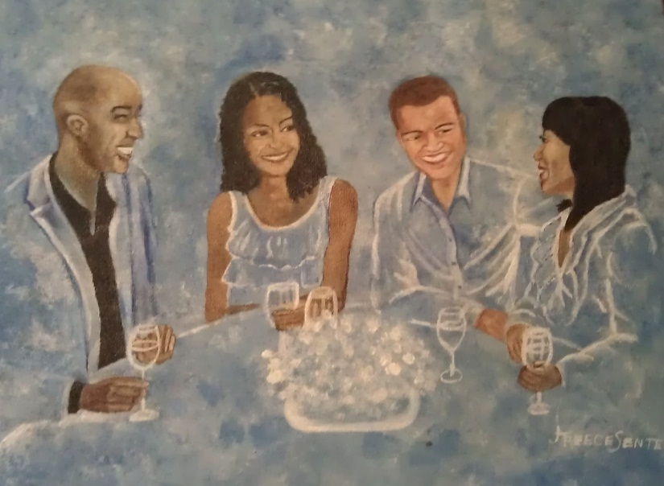
The Rhythm in Blue
Book Club Discussion Guide

Discussion Questions

- Do you think Mason made the right decision when he traveled to spend a few days with Jasmine? Or should he have “stuck it out” until his wedding day?
- Do you believe men and women can have a platonic friendship like Mason and Jaz’?
- Which character is most like you?
- Which character reminded you of one of your friends or family members?
- Do you think Mrs. Jennison should have kept Keisha’s secret? Why or why not?
- Which character’s behavior did you find most frustrating?
- Do you think Mason’s fiancée Sasha was having an affair before she died? Or do you think Mason misunderstood?
- Do you think Mason had a right to be jealous about J.J.?
- Do you think Mason left his boxers in Jaz’ bathroom on purpose?
- Whose storyline did you find most satisfying?
- How would you feel if you were in Frankie’s position? Would you have been upset?
- Jasmine is very “old school” and enjoys cooking and catering to her man. Are you like Jaz? Or would you rather be catered to?
- Do you think Layla should have gone back to Devin’s home after only knowing him for a short time? Have you ever “followed your heart” and gone against what you know to be the right thing to do?
- Do you think Mrs. Jennison was right to feel like her life was wasted by raising her daughter’s child as her own? Or do you think it’s just “part of being a mother?”
- Have you ever made a sacrifice for your child? Did your child every find out about it?
- Would you ever date a person who had been incarcerated? Have you ever dated someone with a “past”?
- If you were in Keisha’s shoes, how would you have reacted to your husband conceiving a child while you were engaged?
- When the house music set came on, Layla couldn’t wait to dance. What type of music always calls you to the dance floor?
- Do you think Sarah was wrong for dropping Joshua off at Jacob’s house before talking to Jacob first?
- Do you think Sarah secretly wants to be back with Jacob? Does she respect Keisha?
- Do you think Mason should have waited a little longer before asking Jasmine to marry him? Which character is your favorite? Why?
- Which character is your least favorite? Why?
- Where do you see the characters in ten years?

Find more discussion questions at www.therhythminblue.com
Book club menu ideas:
Consider serving one of the following meals at your “The Rhythm in Blue” book club discussion.

Big Mama’s Fish and chips (the meal shared by Keisha and Jasmine when they visited Big Mama’s for the first time)
Catfish nuggets
French fries
Salad
Sweet tea

Jasmine’s “Breakfast for dinner”
French toast
Bacon/ turkey bacon
Fresh fruit
OJ/ mimosa

Elm Street Baptist Church Sunday dinner (the meal enjoyed by Mason during his first visit to Elm Street Baptist)
Spiral ham
Baked mac and cheese
Green beans
Cornbread
Red punch

Jasmine and Mason’s “picnic”
Chilled bottle of wine
Assorted cheese/ fruit
Crackers
Checkers game

Layla and Devin’s first dinner together
Shrimp scampi
Pasta
Garlic bread
Spinach salad
Oatmeal cookies

